Brake Chopper

Inhalt

Description 2

Features 2

Function 2

Tests 3

DC-DC Converter 3

Current is independent of voltage 3

Current cutoff below a voltage of 7V 4

No Current should be dissipated if the Power is off 5

Automatic thermal throttling 6

PCB and mounting base 6

Case 7

CAN-Bus Communication 8

# Description

The Brake Chopper is an electronic load device that can be controlled via the CAN-Bus protocol. It is specifically designed to be integrated with an e-bike's power system and serves as a dissipative load, allowing for the dissipation of excess energy that cannot be stored in the battery.

In e-bikes, regenerative braking systems allow for the capture of energy generated during braking, which can then be stored in the battery for later use. However, in situations where the battery is already fully charged or when the regenerative braking system is unable to capture all of the energy generated, the Brake Chopper is employed to dissipate the excess energy as heat.

The Brake Chopper's ability to handle excess energy as a dissipative load makes it an essential component in modern e-bike power systems. With its ability to be controlled via the CAN-Bus protocol, the Brake Chopper can be easily integrated into the overall e-bike control system, enabling accurate and efficient management of energy flow in the system.

# Features

* **Seamless Integration**: The Brake Chopper is designed for easy integration into existing e-bike systems, allowing for a smooth and hassle-free upgrade.
* **12V Input**: The device features a 12V input
* **Wide Battery Input Range**: With a battery input range of 7-100V, the Brake Chopper is compatible with a broad range of e-bike battery systems.
* **Automatic Thermal Throttling Protection**: The device features advanced thermal throttling protection, ensuring safe operation and preventing damage from overheating.
* **High Power Dissipation**: The Brake Chopper is capable of dissipating up to 1250W of power for short periods, making it ideal for handling high-energy situations.
* **Undervoltage Protection**: The device includes undervoltage protection, safeguarding against damage from voltage drops.
* **Automatic CAN Communication**: The Brake Chopper features automatic CAN communication with existing e-bike motor, generator, and battery systems, allowing for seamless integration into the overall power management system.

# Function

The Brake Chopper utilizes five power stages, each consisting of a MOSFET that is controlled by an operational amplifier (op-amp). The op-amp takes the voltage drop across a shunt as feedback to precisely dissipate the set current, ensuring safe operation and preventing damage to the battery and system components. The MOSFETs are operated in the linear region of their characteristic curve to act as resistors, and they are synchronized to rapidly control the load current, thereby dissipating excess current as heat. The use of an op-amp with feedback control ensures precise current regulation and consistent performance. The system is controlled by an STM32 microcontroller unit (MCU), which sets the desired output via a digital-to-analog converter (DAC) and regulates the op-amps for the desired load current.

* Enable pin beschreiben

# Tests

## DC-DC Converter

The printed circuit board (PCB) features two DC-DC converters that regulate the 12V input down to 5V and 3.3V. The converters utilize the ME3116 integrated circuit (IC) with a 54.7kΩ R1 and 10kΩ R2 voltage divider for the 5V output and a 10kΩ R1 and 3kΩ R2 voltage divider for the 3.3V output. The output voltage for the ME3116 is calculated using the following formula: $V_{O}=0,8*\frac{R1+R2}{R2}$.

|  |  |
| --- | --- |
| Calculated Voltage | Measured Voltage |
| $$V_{5V}=0,8*\frac{54,7k+10k}{10k}=5,18V$$ | $V_{5V}=5,16V$ |
| $$V_{3,3V}=0,8*\frac{10k+3k}{3k}= 3,47V$$ | $V_{3,3V}=3,47V$ |

## Current is independent of voltage

The Brake Chopper is designed to consistently dissipate a set current regardless of input voltage. Channel 2, represented by the blue line, displays the current amplifier measuring a 0.01Ω shunt with a gain of 20V/V and an offset of +0.05V. Channel 1, shown by the yellow line, indicates the VBat input voltage.

In a recent test, the current was set to 1.5A (0.35V from current amplifier), and the voltage ranged from 15V to 60V before returning to 15V within a timeframe of 20 seconds. The Brake Chopper successfully dissipated the set current throughout the test.

* As expected the current didn’t change.

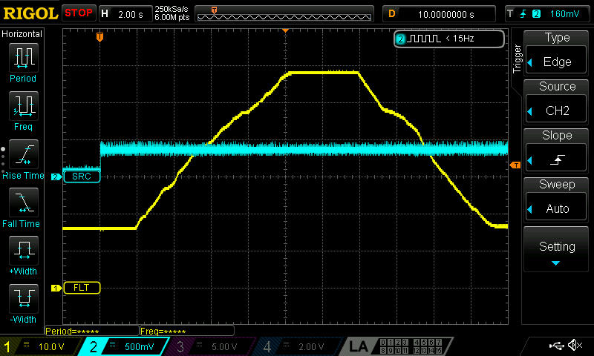

## Current cutoff below a voltage of 7V

As a precautionary measure, the Brake Chopper includes a current cutoff feature that activates when the VBat input voltage drops below 7V. This feature protects the system from damage in the event of a fully discharged battery.

During testing, the current was set to 1.5A, and the initial voltage was 15V. As the voltage was intentionally lowered to less than 7V, the current dropped to zero, as expected, due to the current cutoff feature. After the voltage was raised above 7V, the current resumed its previous value of 1.5A. The Brake Chopper successfully demonstrated its ability to activate the current cutoff feature in response to low VBat (shown in yellow in Channel 1) input voltage. Channel 2, represented by the blue line, displays the current amplifier measuring a 0.01Ω shunt with a gain of 20V/V and an offset of +0.05V.

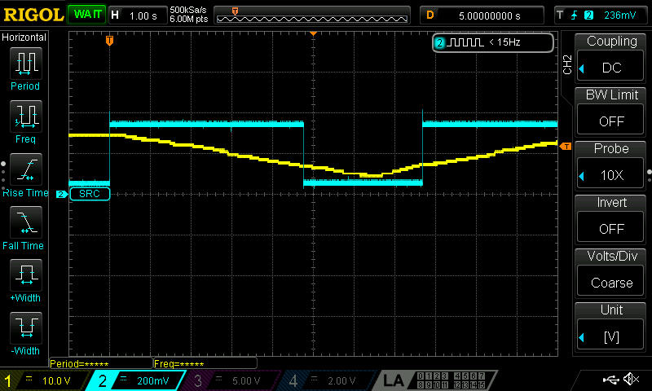

## No Current should be dissipated if the Power is off

To prevent any current flow when the battery is connected before the system is turned on, the Brake Chopper includes a feature that ensures zero current flow under such circumstances. During testing, VBat was connected with 12V (shown in pink in Channel 3), and both the current amplifier (shown in blue in Channel 2) and the voltage over the 0.01Ω shunt (shown in yellow in Channel 1) were measured.

As expected, the Brake Chopper successfully prevented any current flow, and the current remained at zero after VBat was connected. This demonstrates the effectiveness of the feature designed to prevent current flow when the battery is connected prior to system activation.

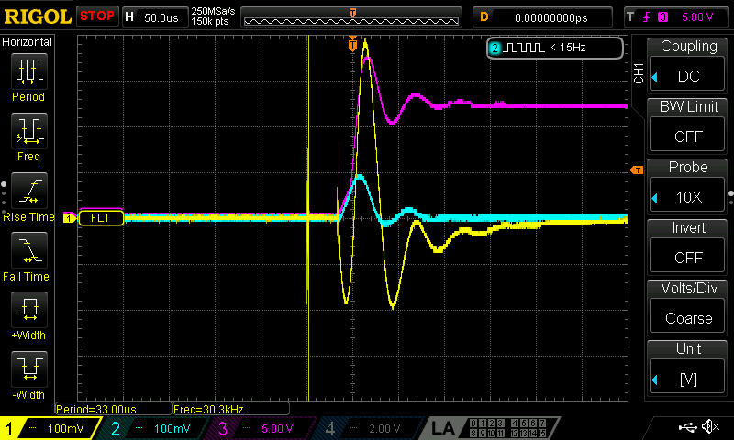

The gate-source voltage of one of the power stages was measured during a repeat of the previous test (depicted in Channel 2 as blue). As anticipated, the control voltage of the MOSFET was driven to zero, and no current was observed to flow through the system.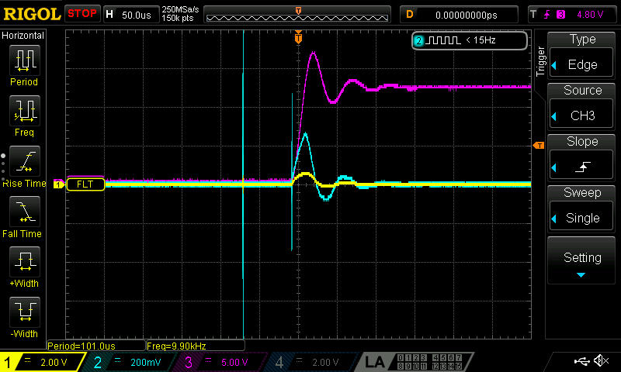

## Automatic thermal throttling

### PCB and mounting base

The system turns off the current flow once the thermistor on the PCB or on the mounting base measures a temperature above 90°C. One thermistor is located on the pcb and one is located on the heatsink. For this test, VBat (shown in yellow in Channel 1) is set to 60V and the current is set to 1,5A and the current gets shut off and turned back on as the temperature passes 90°C. Channel 2, represented by the blue line, displays the current amplifier measuring a 0.01Ω shunt with a gain of 20V/V and an offset of +0.05V. 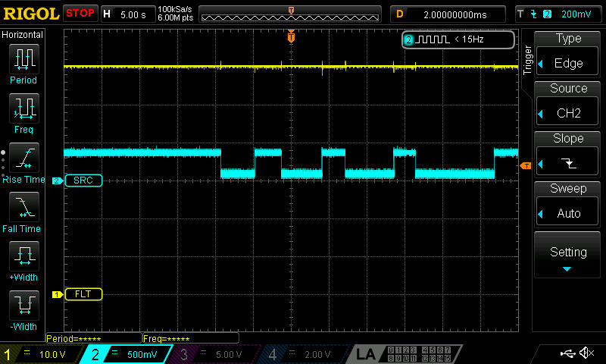

### Case

To ensure user safety, the system implements temperature protection by throttling the current when the temperature of the case exceeds 50°C and completely cutting off the current when it reaches 60°C, as contact with humans should never result in temperatures exceeding 60°C. To verify this functionality, the current is set to 1.5A and the temperature is monitored through one thermistor located on the housing. When the temperature reaches 60°C, the current should drop to zero. Channel 2, shown in blue, displays the current amplifier measuring a 0.01Ω shunt with a gain of 20V/V and an offset of +0.05V. The current is successfully throttled and eventually cut off as the temperature exceeds 60°C.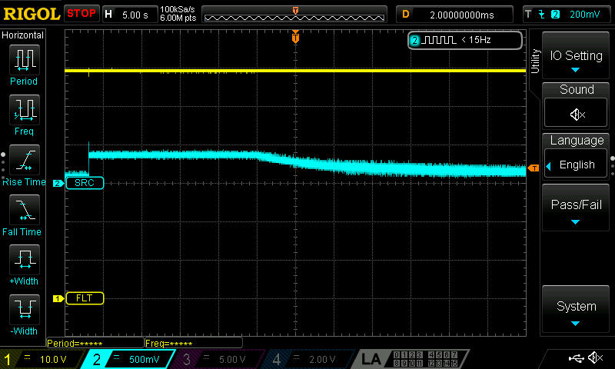

## CAN-Bus Communication

The brake chopper transmits a status message every second, following the structure outlined in the table below.

|  |  |  |  |  |  |  |  |  |  |  |
| --- | --- | --- | --- | --- | --- | --- | --- | --- | --- | --- |
| **Gesendete Nachrichten** | **Nachricht** | | | | | | | | | |
| Wertebereich | Einheit | factor | ofset | Name | ID | Start Bit | Länge [bit] | DLC | Typ |
| **INFO_Msg** |  |  |  |  | **INFO_Msg** | **0x400-0x4F0** |  |  | 5 | s |
| **Aktuell aufgenommener Strom** | 0-65535 | mA | 1 | 0 |  |  | 0 | 16 |  | Unsigned |
| **Aktuelle maximale Stromsaufnahme** | 0-65535 | mA | 1 | 0 |  |  | 16 | 16 |  | Unsigned |
| **Temperatur PCB** | `-50 bis 200` | C | 1 | 0 |  |  | 32 | 8 |  | Unsigned |

The following data presents the CAN messages recorded during the case thermal throttling test. As observed in the last message, the dissipated current is throttled down from 1500mA to 312mA as the temperature approaches 60°C, the maximum allowable temperature for the case to come in contact with humans. The temperature reading in the last message is 57°C.

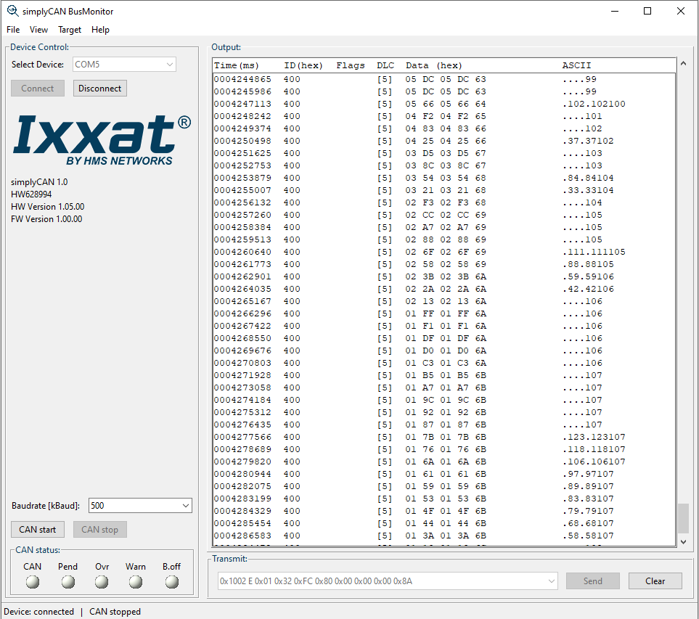

The presented graph depicts the results of a test conducted to assess the response time of the system to incoming CAN messages. The yellow line in Channel 1 represents the VBat signal, the blue line in Channel 2 displays the current amplifier signal, and the pink line in Channel 3 shows the CAN-High signal. The test was performed by sending a CAN message to the system and measuring the time delay until the current was dissipated. The delay was measured to be 35ms.